**DAILY ONLINE ACTIVITIES SUMMARY**

|  |  |  |  |  |  |  |  |  |
| --- | --- | --- | --- | --- | --- | --- | --- | --- |
| **Date:** | **3-06-2020** | | | | | **Name:** | **Kavya** | |
| **Sem & Sec** | **6th & A** | | | | | **USN:** | **4al17cs041** | |
| **Online Test Summary** | | | | | | | | |
| **Subject** | | **PAP ASSIGNMENT TEST** | | | | | | |
| **Max. Marks** | | **20** | | **Score** | | | **06** | |
| **Certification Course Summary** | | | | | | | | |
| **Course** | WEKA tool for data preparation, classification, regression, clustering, association rules mining, and visualization | | | | | | | |
| **Certificate Provider** | | | **Udemy** | | **Duration** | | | **3 Hours 30 min** |
| **Coding Challenges** | | | | | | | | |
| **Problem Statement:1.** Write a Java Program to Implement Circular Doubly Linked List  2. Take a list of length 3 containing integers, find out which is larger, first or last one and set all the elements in the list to be that value. Print the updated list.  3. Write a python program to generate prime number in an interval | | | | | | | | |
| **Status:Yes I have uploaded all the programs given** | | | | | | | | |
| **Uploaded the report in Github** | | | | | **Yes** | | | |
| **If yes Repository name** | | | | | [**https://github.com/kavya-077/DAILY-STATUS**](https://github.com/kavya-077/DAILY-STATUS) | | | |
| **Uploaded the report in slack** | | | | | **Yes** | | | |

Online Test Details: (Attach the snapshot and briefly write the report for the same)

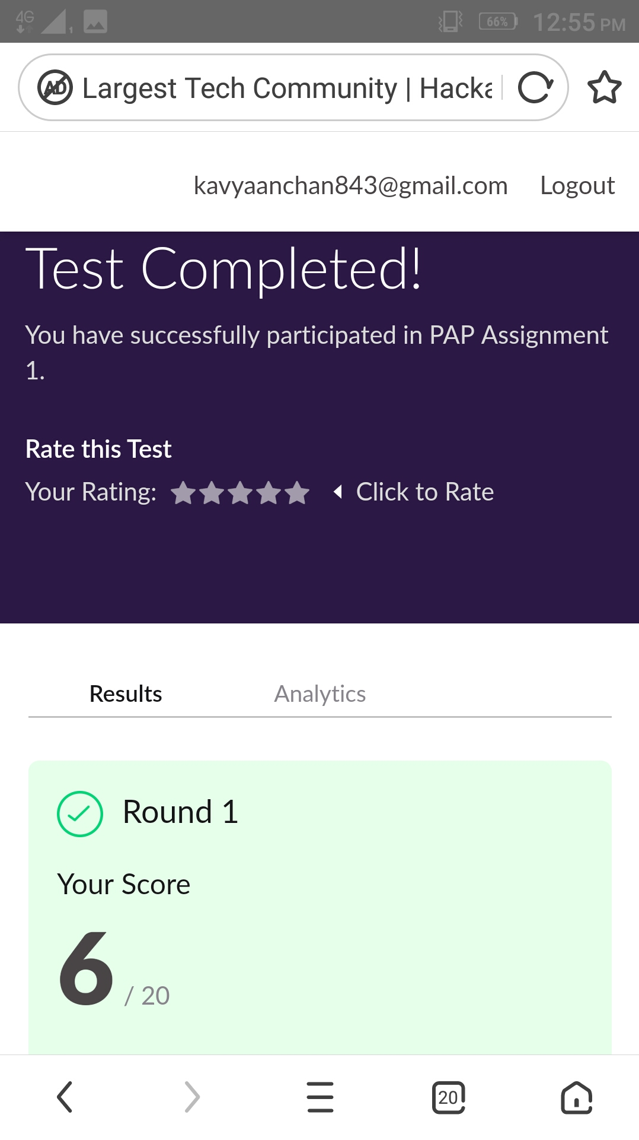

Certification Course Details: (Attach the snapshot and briefly write the report for the same)

WEKA tool for data preparation, classification, regression, clustering, association rules mining, and visualization

**What we’ll learn**

* We can learn WEKA tool for data pre-processing, classification, regression, clustering, association rules, and visualization

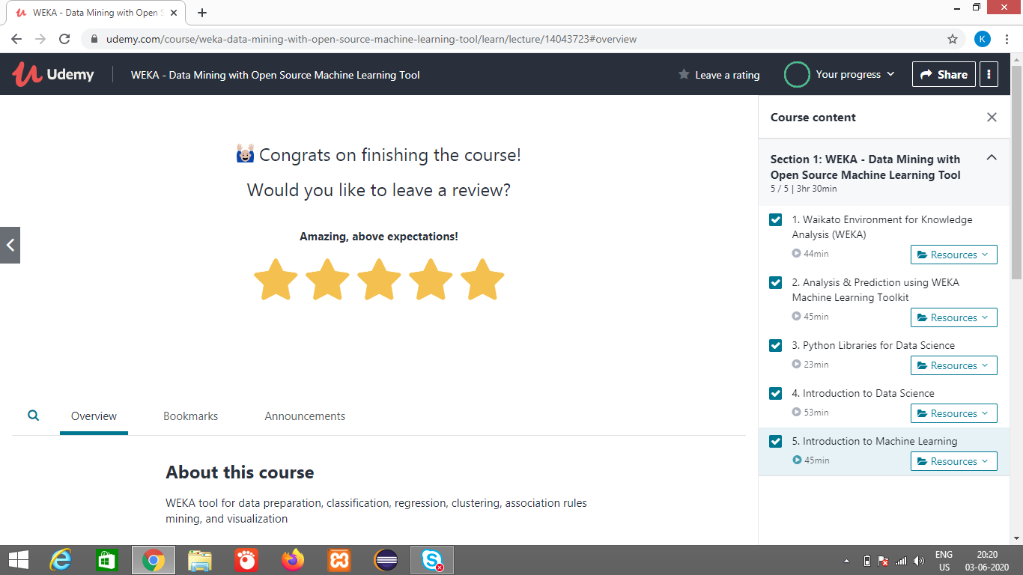

<https://github.com/alvas-education-foundation/kavya-onlinecourse>

Coding Challenges Details: (Attach the snapshot and briefly write the report for the same)

<https://github.com/kavya-077/DAILY-STATUS>

<https://github.com/alvas-education-foundation/kavya-OCA>